Assignment 1 Report

Jacob Reichard
Daniel Lineberger
The purpose of this assignment was to take in a shape and apply various transformations on it using Octave. First, we load in the 2D matrix (figure.txt) and assign it to our ‘var’ variable. We let ‘x’ be all of the 1st column elements of the matrix, and we let ‘y’ be all of the 2nd column elements of the matrix. The figure is centered to the x and y axes. The figure is plotted onto a graph using Octave’s plot() function.

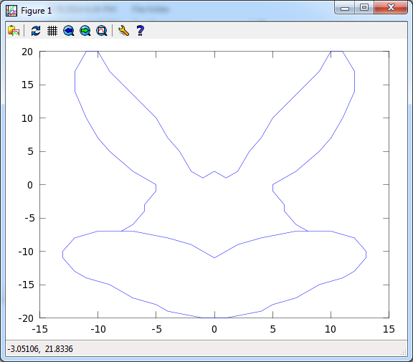

Next, a transform string is loaded into the variable ‘translist’, which is then used to create new variables ‘transforms’ and ‘translation’. ‘Transforms’ becomes a 2 x 2 shear matrix, and ‘Translation’ becomes a 1 x 2 matrix. The function transform_figure takes in our previously calculated x and y coordinates, and the shear matrix as the third argument. The transform matrix is multiplied onto the coordinates and the results are assigned to the ‘new_figure’ variable. Again, the ‘x’ and ‘y’ variables consist of all of the 1st column elements and all of the 2nd column elements, respectively. We calculate the axes ranges from the min and max values of x and y. Finally, we call plot() x and y.

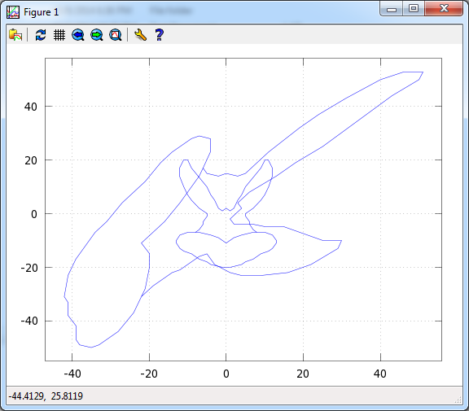

For Part 3, we define a string that represents an affine map which gets split into a 2x2 matrix called ‘axiss’ and a 1x1 matrix called ‘origins’. We assign a copy of the original ‘var’ figure to a new variable ‘fun’ and calculate its size. For every i^{th} element in ‘fun’, we multiply our 2x2 matrix ‘axis’ with its transpose, add our 1x1 ‘origins’ matrix, and transpose the result one last time. Lastly, we add 1 to every 2nd column in the i^{th} row. A new axes are generated, and we plot our new figure.

